**I/O BUS and Interface Module**

**I/O Bus and Interface Module define the typical communication link between the processor and several peripherals.**

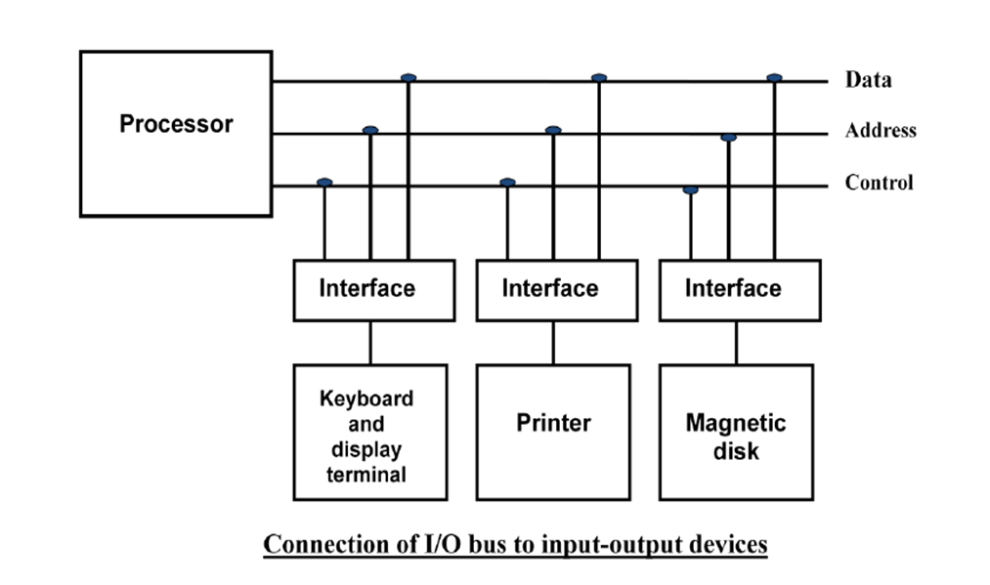

**The I/O Bus consists of data lines, address lines and control lines.**

**The I/O bus from the processor is attached to all peripherals interface.**

**To communicate with a particular device, the processor places a device address on address**

**lines.**

**The magnetic disk, printer and terminal are worked practically in any general purpose computer. The magnetic tape is used in some computers for backup storage.**

**Each peripheral device has associated with it an interface unit. Each Interface decodes the address and control received from the I/O bus, interprets them for peripherals and provides signals for the peripheral controller.**

**It is also synchronizes the data flow and supervises the transfer between peripheral and**

**processor.**

**Each peripheral has its own controller that operates the electromechanical device.**

**For example, the printer controller controls the paper motion, the print timing and the selection of printing characters.**

**The I/O bus from the processor is attached to all peripheral interfaces. To communicate with a particular device, the processor places a device address on the address lines. Each interface attached to the I/O bus contains an address decoder that monitors the address lines. When the interface detects its own address, it activates the path between the bus lines and the device that it controls. All peripherals whose address does not correspond to the address in the bus are disabled by their interface.**

**At the same time that the address is made available in the address lines, the processor provides a function code in the control lines. The interface selected responds to the function code and proceeds to execute it. The function code is referred to as an I/O command.**

**The control lines are referred as I/O command. The commands are as following:**

**Control command- A control command is issued to activate the peripheral and to inform it**

**what to do.**

**Status command- A status command is used to test various status conditions in the interface**

**and the peripheral.**

**Data Output command- A data output command causes the interface to respond by transferring data from the bus into one of its registers.**

**Data Input command- The data input command is the opposite of the data output.**

**In this case the interface receives an item of data from the peripheral and places it in its**

**buffer register.**

**I/O Versus Memory Bus**

**To communicate with I/O, the processor must communicate with the memory unit. Like the**

**I/O bus, the memory bus contains data, address and read/write control lines. There are three ways that computer buses can be used to communicate with memory and I/O:**

**1. Use two Separate buses, one for memory and other for I/O.**

**2. Use one common bus for both memory and I/O but separate control lines for each.**

**3. Use one common bus for memory and I/O with common control lines.**

**I/O Processor**

**In the first method, the computer has independent sets of data, address and control buses, one for accessing memory and other for I/O. This is done in a computer that provides a separate I/O processor (IOP) in addition to the CPU. The IOP also communicates with the input and output devices through a separate I/O bus with its own address, data and control lines. The purpose of IOP is to provide an independent pathway for the transfer of information between external device and internal memory. The I/O processor is sometimes called a data channel.**